**Selenium Locators Assignment:**

**Problem 1**- Open <https://www.phptravels.net/hotels> website and locate the following and Write xpath.

* PHPTRAVLES Logo
* Home
* Flights
* Tours
* Company
* Signup Btn
* Login Btn
* Agents DropDown

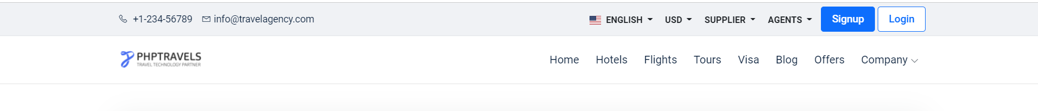

*Note - You have to use Id, Name, Class, CSS Selector, TagName and write Relative and absolute xpath*

**Problem 2**- Write **Xpath** for Below Web elements using Xpath Axes (such as preceding, following, ancestor, following-sibling etc..)

* Check in - Calendar Icon
* Check Out – Calendar Icon
* “- ” for Adults
* “+” for Adults
* “-“ for Childs
* “+” for Childs

Solution 1:

1)phptravles logo

- id-> //img[@id='logo]

-name-> //img[@src=   
<https://phptravels.net/api/uploads/global/logo.png> ]

-class->*[@class='logo']

-CSS Selector->("a[href='/wave-effect']")

-tag ->**//tagname[@Attribute=’logo’]**

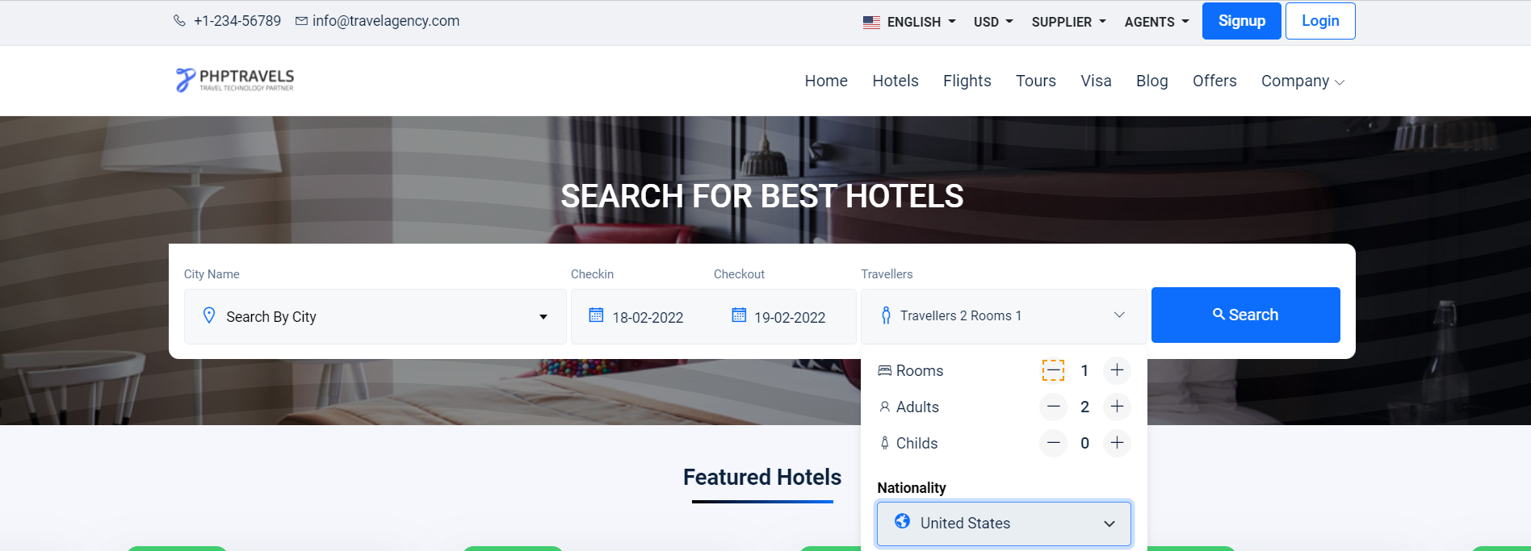

**Note : Don’t Use Indexes**